Added new signs showing in below screen

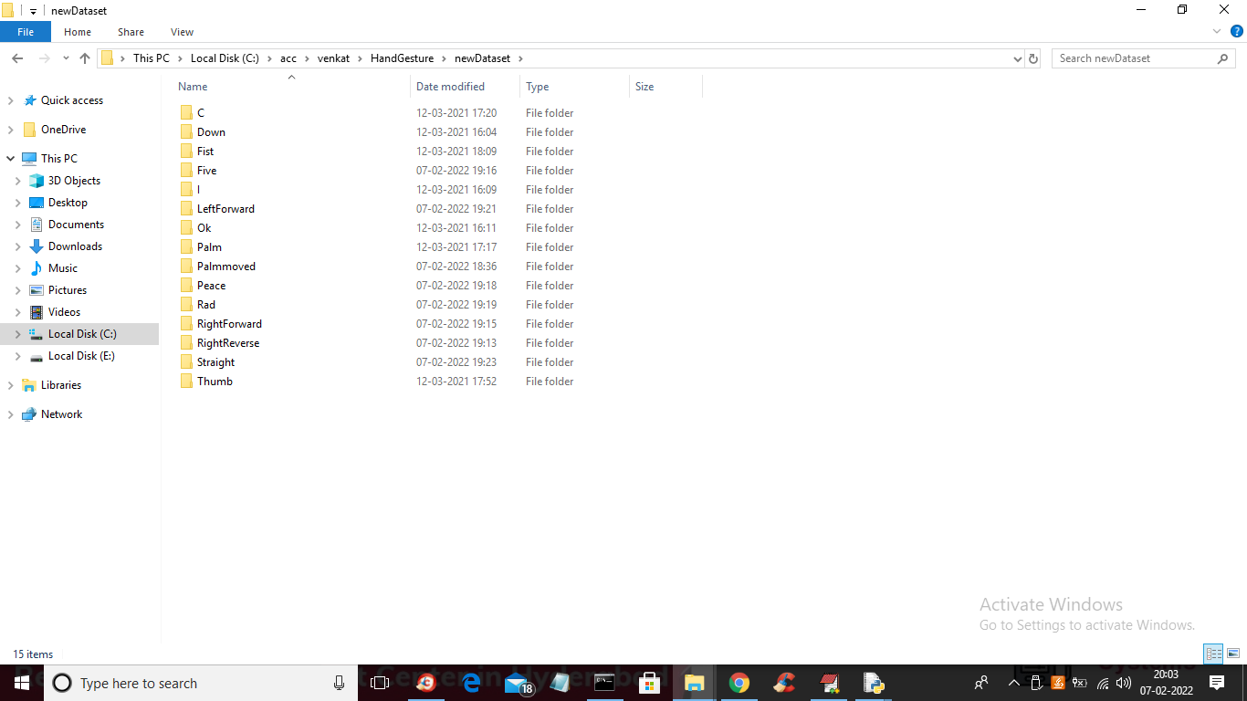

In above screen show all five fingers to get five recognition like below screen

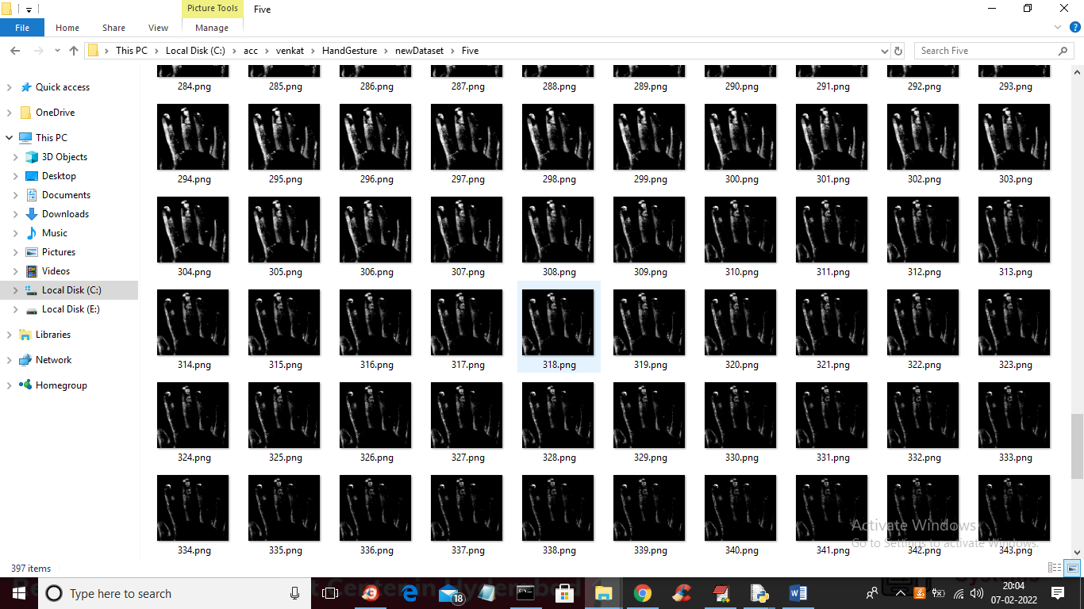

Show two fingers to get peace sign like below screen

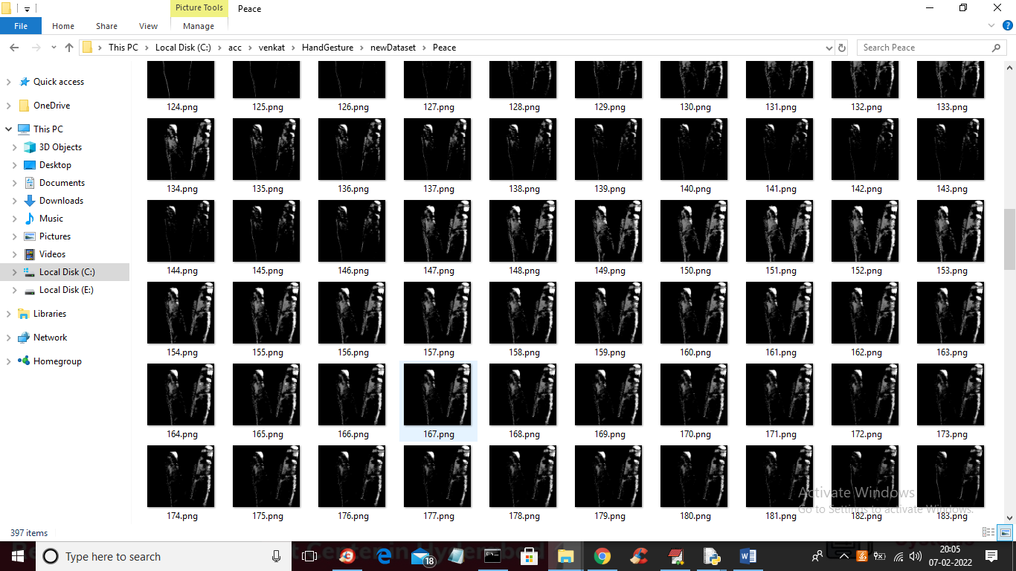

Revers hand two fingers should be shown and 3 fingers for “Right Reverse”

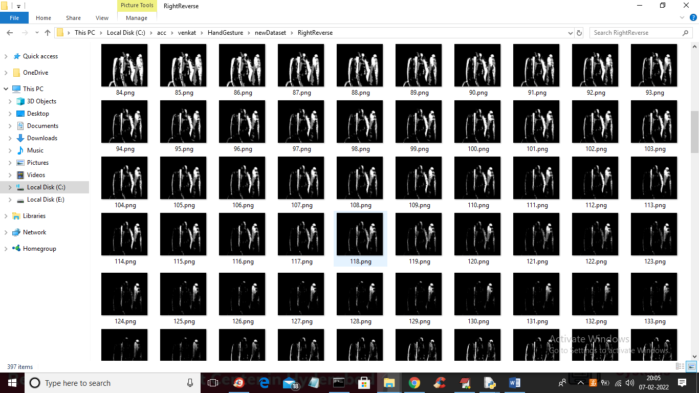

Show 4 fingers for “Right Forward” like below screen

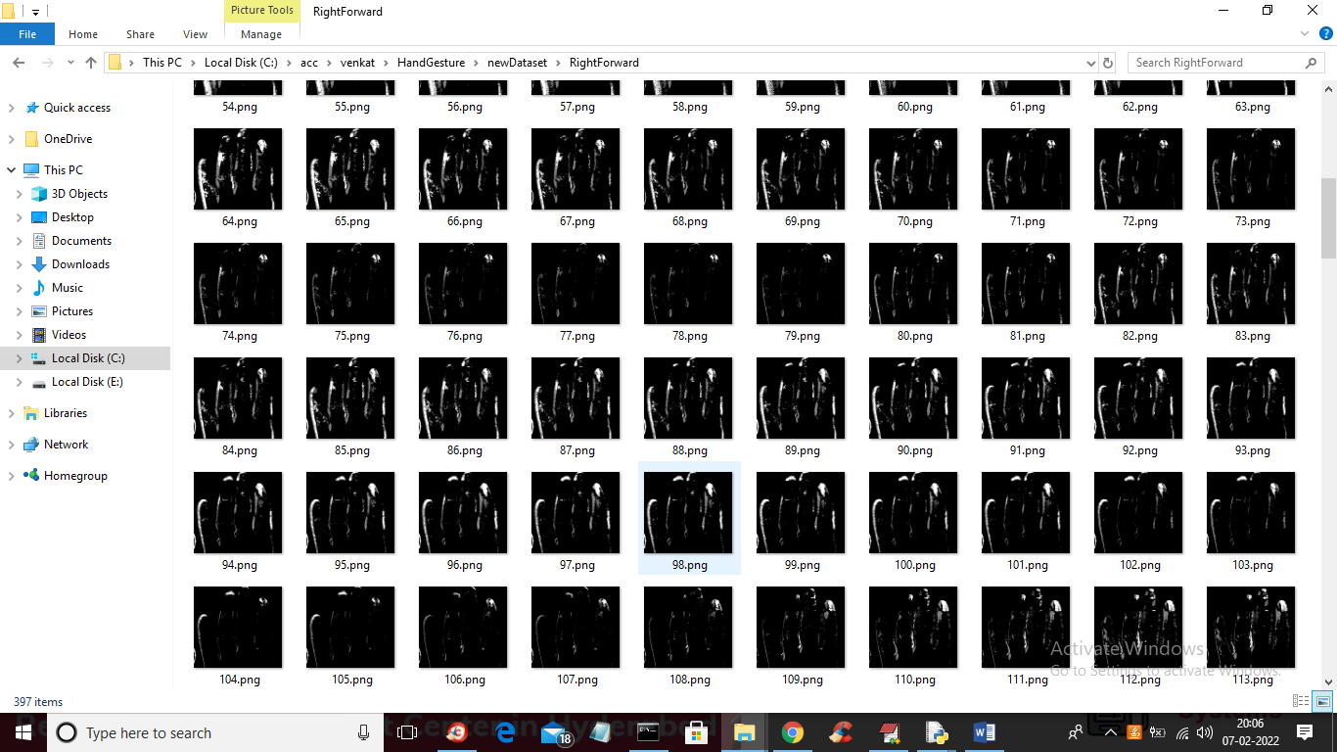

Similarly in new dataset folder whatever signs showing you can show those signs to camera to get output

